Chapter - 1 ⇒ Introduction to CSS
1.1. Introduction of CSS
CSS is the language we use to style an HTML document.
CSS describes how HTML elements should be displayed.
1.2. What is CSS ?
CSS stands for
‘Cascading Style Sheet'
.
CSS describes how HTML elements are to be displayed on screen.
CSS is the language that is used to style HTML documents.
1.3. What is use or purpose of CSS?
It is a style sheet language which is used to describe the look and
formatting of a document written in markup language.
It provides an additional feature of HTML.
It is generally used with HTML to change the Style of web pages and user
interfaces.
It is easier to make the web pages presentable using CSS.
It is easy to learn and understand and used to control the presentation of
an HTML document.
CSS helps us to control the text color, font style, the spacing between
paragraphs, sizing of columns, layout designs, and many more.
1.4. History of CSS
1994⇒ ‘ Hakon Wium Lie ’ proposed the idea of CSS.
Till time there are 3 versions of CSS introduced
Now we are using the latest version of CSS i.e.
CSS3
CSS1 (1996):
The first official specification released in →
1996
It allowed basic features.
Basic Features like ⇒ Styling such as changing text colors, fonts, and
backgrounds colors.
Also it provide the limited layout control to HTML document.
CSS2 (1998):
The second official specification released in →
1998
Introduced with new features.
New Features such as ⇒ positioning, Z-index, and the introduction of
media types for different devices.
Improved control over layout to HTML document.
CSS3 (2011 - Ongoing):
The first draft of CSS3 released in →
1999
CSS3 is not a single monolithic release but a collection of modular
specifications introduced gradually.
Modular Approach ⇒ Divided into modules.
These modules cover various aspects of web design, such as
animations, gradients, and flexible box, grid layout, etc.
CSS4 (2020 - in development):
CSS4 is the future of CSS, aiming to further enhance web design
capabilities, including responsive design, variable fonts, and improved
grid systems.
1.5. CSS History Timeline
1994
⇒ Hakon Wium Lie proposed the idea of CSS.
1996
⇒ The first version of CSS was invented.
1998
⇒ CSS2 was released and work on CSS3 began.
2011 - ongoing
⇒ CSS3 was different from other versions. Also it fixed errors
found in CSS2. CSS3 begins to roll out as a collection of modular
specifications, enabling advanced styling and interactivity.
2020s
⇒ CSS4 is in development, poised to bring even more advanced
features to the world of web design.
1.6. Syntax of CSS
A CSS rule consists of a selector and a declaration block.
Syntax ⇒
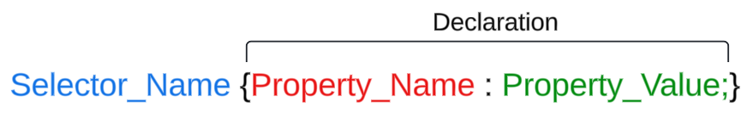
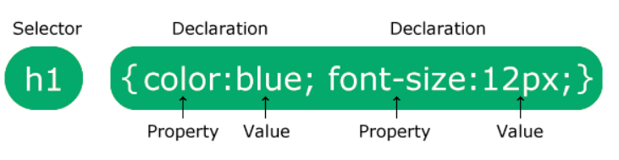
1.7. Implementation of CSS → Ways to add CSS (3)
There are three ways of inserting a style sheet :
1. Inline CSS
2. Internal CSS
3. External CSS

1. Inline CSS :
An inline style is used to apply a unique style for a single element.
Inline CSS is written inside an HTML tag with the
style attribute.
The style attribute can contain any CSS property.
How to Add Inline CSS to HTML
⇒
Here's the syntax for Inline CSS ⇒
<!-- one declaration -->
<element style="property: value;">
<!-- multiple declarations -->
<element style="property: value; property: value;">
2. Internal CSS :
An internal style sheet is used if we want to provide style for single
HTML page.
Internal CSS is written inside a <style> element, which goes inside
the <head> of the HTML document.
3. External CSS :
External CSS is written in a separate file called an external stylesheet, and linked to the HTML document with a <link>
tag inside a <head>
We create a separate CSS file is called an external stylesheet.
This file ends with the extension .css
With an external stylesheet , we can change the look of an entire
website by changing just one file
4. import :
The @import rule allows us to import a style sheet into another style
sheet.
The @import rule must be at the top of the document
Syntax ⇒
@import url(path_of_css_file_you_want_to_import); //By p
assing path directly.
@import url("String_path"); //With the help of String we
can pass Path.

Chapter - 2 ⇒ CSS Selectors
1.1. What is mean by selectors?
CSS selectors are used to find or select the HTML elements you want to style.
1.2. Types of Selectors
We can divide CSS selectors into 5 categories:
1. Simple Selector
2. Combinator Selector
3. Attribute Selector
4. Pseudo Class Selector
5. Pseudo Element Selector

1. Simple Selector (4)
Simple Selectors are classified into 4 types :
1. Id Selector (#)
2. Class Selector (.)
3. Element Selector (tagname)
4. Universal Selector (*

1. Id Selector (#)
The id selector uses the id attribute of an HTML element to select a
specific element.
The id of an element is unique within a page, so the id selector is used to select one unique element.
To select an element with a specific id, write a hash (#) character,

Syntax ⇒
#id_name {
/* style definations */
key : value;
}

2. Class Selector (.)
The class selector selects HTML elements with specific class attribute.
Syntax ⇒
.class_name {
/* style definations */
key : value;
}

3. Element Selector (tagname)
The element selector selects the HTML elements based on the element name or tagname .
Example ⇒ h1, p, div, span, etc.
Syntax ⇒
element_name {
/* style definations */
key : value;
}

4. Universal Selector (*)
The universal selector (*) in CSS is used to select all the elements in an HTML document.
It also includes other elements which are inside under another element.
Syntax ⇒
* {
/* style definations */
key : value;
}

5. Grouping Selector
The Group selector is used to style all comma-separated elements with
the same style.
Note:
Suppose you want to apply common styles to different selectors,
instead of writing rules separately you can write them in groups

2. Combinator Selector (4)
A CSS selector can contain more than one selector.
It defines the relationship between two selectors.
There are 4 different combinators in CSS:
1. Descendent Selector (space)
2. Child Selector (>)
3. Adjacent Sibling Selector (+)
4. General Sibling Selector (~)
1. Descendent Selector (space)
The descendent selector matches all the elements that are descendants
of specified element.
It uses the
space
as the separator between the elements.
The word descendent indicates anywhere in the DOM tree.
It can be a direct child or deeper than five levels, but it will still referred
as descendent.
First Selector → Ancestor (Parent, Parent’s parent, etc.)
Second Selector → Descendent or Successor.
Syntax ⇒
element element {
/* Style definations */
}
Example-1 ⇒
<!DOCTYPE html>
<html lang="en">
<head>
<meta charset="UTF-8" />
<meta name="viewport" content="width=device-width, i
nitial-scale=1.0" />
<title>Descendent Selector</title>
<style>
div h1 {
color: blue;
}
ul li {
color: red;
}
</style>
</head>
<body>
<div>
<h1>Descendent Selector (Space)</h1>
<ul>
<li>HTML</li>
<li>CSS</li>
<li>JS</li>
</ul>
</div>
</body>
</html>
Example-2 ⇒
<!DOCTYPE html>
<html lang="en">
<head>
<meta charset="UTF-8" />
<meta name="viewport" content="width=device-width, i
nitial-scale=1.0" />
<title>Descendent Selector</title>
<style>
div p {
color: red;
}
</style>
</head>
<body>
<div>
<p>Paragraph-1</p>
<p>Paragraph-2</p>
<span>
<p>Paragraph-3</p>
<p>Paragraph-4</p>
</span>
<p>Paragraph-5</p>
</div>
</body>
</html>
2. Child Selector (>)
The child selector, selects all the elements that are the children of a
specified element.
It uses the
greater than (>)
sign as the separator between the elements.
It only selects those elements that are the direct child of the specified
element.
Syntax ⇒
element > element {
/* Style definations */
}
Example ⇒
<!DOCTYPE html>
<html lang="en">
<head>
<meta charset="UTF-8" />
<meta name="viewport" content="width=device-width, i
nitial-scale=1.0" />
<title>Child Selector</title>
<style>
/* Child Selector */
div > p {
color: red;
background-color: yellow;
}
</style>
</head>
<body>
<div>
<h1>Heading-1</h1>
<p>Paragraph-1</p>
<article>
<p>Paragraph-2</p>
</article>
<p>Paragraph-3</p>
</div>
</body>
</html>
3. Adjacent Sibling Selector (+)
The adjacent sibling selector is used to select an element that is directly
after another specified element.
It uses plus (+) sign as the separator between the elements.
Sibling means must have the same parent element and “adjacent”
means “immediately following”.
The sibling selector, selects the adjacent element or we can say that the
element which is next to the specified tag.
It only selects the element which is next to the specified first element.
Syntax ⇒
element + element {
/* Style definations *
}
Example ⇒
<!DOCTYPE html>
<html lang="en">
<head>
<meta charset="UTF-8">
<meta name="viewport" content="width=device-width, i
nitial-scale=1.0">
<title>Adjacent Sibling Selector (+)</title>
<style>
p + p {
color: red;
background-color: yellow;
}
</style>
</head>
<body>
<div>
<h1>Heading-1</h1>
<p>Para-1</p>
<p>Para-2</p>
<span>
<p>Para-3</p>
<p>Para-4</p>
</span>
<p>Para-5</p>
</div>
</body>
</html>
4. General Sibling Selector (~)
The general sibling selector, selects all the elements that are next
siblings of a specified element even though they are adjacent or not.
It uses the tilde (~) sign as the separator between the elements.
It can be used for selecting the group of elements that share common parent element.
It is useful when we have to select of an element even if they are not adjacent directly.
Syntax ⇒
element ~ element {
/* Style definations */
}
Example ⇒
<!DOCTYPE html>
<html lang="en">
<head>
<meta charset="UTF-8">
<meta name="viewport" content="width=device-width, i
nitial-scale=1.0">
<title>General Sibling Selector</title>
<style>
h1 ~ p {
color: maroon;
background-color: wheat;
}
</style>
</head>
<body>
<h1>Heading-1</h1>
<p>Para-1</p>
<div>
<p>Para-2</p>
</div>
<p>Para-3</p>
<p>Para-4</p>
</body>
</html>

4. Pseudo Class Selector (3)
A pseudo-class is a selector that selects elements that are in a specific
state
e.g. they are the first element of their type, or they are being hovered over
by the mouse pointer.
Pseudo-classes are keywords that start with a
colon (:)
.
For example,
:hover
is a pseudo-class.
Syntax ⇒
selector:pseudo-class {
property: value;
}
1. Dynamic Pseudo Class Selector (5)
Dynamic pseudo classes are divided mainly in 5 types are as follows :
1. :link
2. :visited
3. :active
4. :focus
5. :hover
1. link
It is used to provide special effect for unvisited link.
2. visited
The
:visited
selector is used to select visited links.
3. active
Applies styles when an element is activated by the user, such as
clicking a button.
The
:active
pseudo-class is used to select and style an element that
is being activated by the user.
Note =>
:active
MUST come after
:hover
(if present) in the CSS
definition in order to be effective!
4. hover
Applies styles when the mouse pointer is over an element.
The
:hover
selector is used to select elements when you mouse
over them.
5. focus
When an element receives focus, such as when an input field is
selected, the styling property
:focus
is applied.
Example ⇒
<!DOCTYPE html>
<html lang="en">
<head>
<meta charset="UTF-8">
<meta name="viewport" content="width=device-width, i
nitial-scale=1.0">
<title>Dynamic Psuedo Class Selector</title>
<style>
a:link {
color: red;
}
a:visited {
color: green;
}
a:active {
color: blue;
text-decoration: underline;
}
a:hover {
color: hotpink;
}
input:focus {
background-color: greenyellow;
}
</style>
</head>
<body>
<h1>Dynamic Psuedo Classes</h1>
<a href="https://www.w3schools.com/css/css_pseudo_cl
asses.asp">Visit W3School</a> <br> <br>
<form action="">
<label for="">Name:</label>
<input type="text" name="" id="">
</form>
</body>
</html>
2. Structural Pseudo Class Selector (5)
Structural pseudo-classes are a subset of CSS pseudo-classes that
allow you to select and style elements based on their position in the
document tree.
Based on this some of most used structural pseudo class selectors are
as below mentioned :
1. :first-child
2. :last-child
3. :nth-child()
4. :first-of-type
5. :last-of-type
1. first-child
Selects the first child element of its parent.
The
:first-child
pseudo matches a specified element that is the first
child of another element.
Example ⇒
<!DOCTYPE html>
<html lang="en">
<head>
<meta charset="UTF-8">
<meta name="viewport" content="width=device-width,
initial-scale=1.0">
<title>Structural Psuedo Class Selector</title>
<style>
p:first-child {
color: red;
}
</style>
</head>
<body>
<h1>Structural Pseudo Classes</h1>
<p>This is paragraph-1</p>
<p>This is paragraph-2</p>
<div>
<p>This is paragraph-3</p>
<p>This is paragraph-4</p>
</div>
<p>This is paragraph-5</p>
</body>
</html>
2. last-child
Selects the last child element of its parent.
The
:last-child
pseudo matches a specified element that is the last
child of another element.
Example ⇒
<!DOCTYPE html>
<html lang="en">
<head>
<meta charset="UTF-8">
<meta name="viewport" content="width=device-width,
initial-scale=1.0">
<title>Structural Psuedo Class Selector</title>
<style>
p:last-child {
color: blue;
}
</style>
</head>
<body>
<h1>Structural Pseudo Classes</h1>
<p>This is paragraph-1</p>
<p>This is paragraph-2</p>
<div>
<p>This is paragraph-3</p>
<p>This is paragraph-4</p>
</div>
<p>This is paragraph-5</p>
</body>
</html>
3. nth-child()
The
:nth-child()
selector matches of every element that is nth child
of its parent .
n can be number, keyword (even or odd), etc.
Example ⇒
<!DOCTYPE html>
<html lang="en">
<head>
<meta charset="UTF-8">
<meta name="viewport" content="width=device-width,
initial-scale=1.0">
<title>Structural Psuedo Class Selector</title>
<style>
div:nth-child(2) {
background-color: red;
}
p:nth-child(2) {
background-color: yellow;
}
</style>
</head>
<body>
<div>
<p>Paragraph-1</p>
<p>Paragraph-2</p>
</div>
<div>
<p>Paragraph-3</p>
<p>Paragraph-4</p>
</div>
<div>
<p>Paragraph-5</p>
<p>Paragraph-6</p>
</div>
<div>
<p>Paragraph-7</p>
<p>Paragraph-8</p>
</div>
</body>
</html>
4. first-of-type
The
:first-of-type
selector matches every element that is the first
child of a particular type of its parent.
Example ⇒
<!DOCTYPE html>
<html lang="en">
<head>
<meta charset="UTF-8">
<meta name="viewport" content="width=device-width,
initial-scale=1.0">
<title>Structural Psuedo Class Selector</title>
<style>
p:first-of-type {
background-color: yellowgreen;
color: red;
}
</style>
</head>
<body>
<div>
<p>Paragraph-1</p>
<p>Paragraph-2</p>
</div>
<div>
<p>Paragraph-3</p>
<p>Paragraph-4</p>
</div>
<div>
<p>Paragraph-5</p>
<p>Paragraph-6</p>
</div>
<div>
<p>Paragraph-7</p>
<p>Paragraph-8</p>
</div>
</body>
</html>
5. last-of-typez
The
:last-of-type
selector matches every element that is the last
child of a particular type of its parent.
Example ⇒
<!DOCTYPE html>
<html lang="en">
<head>
<meta charset="UTF-8">
<meta name="viewport" content="width=device-width,
initial-scale=1.0">
<title>Structural Psuedo Class Selector</title>
<style>
p:last-of-type {
background-color: wheat;
color: red;
}
</style>
</head>
<body>
<div>
<p>Paragraph-1</p>
<p>Paragraph-2</p>
</div>
<div>
<p>Paragraph-3</p>
<p>Paragraph-4</p>
</div>
<div>
<p>Paragraph-5</p>
<p>Paragraph-6</p>
</div>
<div>
<p>Paragraph-7</p>
<p>Paragraph-8</p>
</div>
</body>
</html>
3. UI Element Pseudo Class Selector (3)
There are mainly 3 types of UI element pseudo class selector are there
in CSS :
1. :enabled
2. :disabled
3. :checked
1. enabled
The
:enabled
pseudo-class represents user interface elements that
are in an enabled state.
Such elements have a corresponding disabled state.
2. disabled
The
:disabled
pseudo-class represents user interface elements that
are in a disabled state.
Such elements have a corresponding enabled state.
3. checked
Radio and checkbox elements can be toggled by the user.
Some menu items are “checked” when the user selects them.
When such elements are toggled “on” the
:checked
pseudo-class
applies.
While the
:checked
pseudo-class is dynamic in nature, and can
altered by user action, since it can also be based on the presence of
semantic attributes in the document, it applies to all media.
Example ⇒
<!DOCTYPE html>
<html lang="en">
<head>
<meta charset="UTF-8">
<meta name="viewport" content="width=device-width,
initial-scale=1.0">
<title>UI Element Pseudo Class Selector</title>
<style>
input:enabled {
background-color: red;
}
input[type = "email"]:disabled{
background-color: grey;
}
input:checked{
outline: 1px solid red;
}
</style>
</head>
<body>
<form action="">
<label for="">First Name</label>
<input type="text" name="" id=""> <br> <br>
<label for="">Email</label>
<input type="email" name="" id="" value="abc@g
mail.com" disabled="disabled"> <br> <br>
<label for="">Gender</label>
<input type="checkbox" name="" id="" checked>
<label for="">Male</label>
</form>
</body>
</html>
5. Pseudo Element Selector ()
A CSS pseudo-element selector is used to style specified parts of an
element.
Syntax ⇒
selector :: pseudo-element {
property : value;
}
There are many pseudo elements in CSS but the ones which are most
commonly used are as follows :
1. ::first-line
2. ::first-letter
3. ::before
4. ::after
5. ::marker
6. ::selection
1. first-line
The
::first-line
pseudo-element is used to add a special style to the
first line of a text.
Note =>
The
::first-line
pseudo-element can only be applied to block
level elements.
Example ⇒
<!DOCTYPE html>
<html lang="en">
<head>
<meta charset="UTF-8" />
<meta name="viewport" content="width=device-width, init
<title>Pseudo Element Selector</title>
<style>
p::first-line {
color: red;
font-size: 20px;
}
</style>
</head>
<body>
<div>
<p>
Lorem ipsum dolor sit amet consectetur adipisicing
consequuntur placeat iure assumenda reprehenderit b
incidunt?
</p>
<p>
Lorem ipsum dolor sit amet consectetur adipisicing
consequuntur placeat iure assumenda reprehenderit b
incidunt?
</p>
</div>
</body>
</html>
2. first-letter
The ::first-letter pseudo-element is used to add a special style to the
first letter of a text.
Example ⇒
<!DOCTYPE html>
<html lang="en">
<head>
<meta charset="UTF-8" />
<meta name="viewport" content="width=device-width, i
nitial-scale=1.0" />
<title>Pseudo Element Selector</title>
<style>
p::first-letter{
color: green;
font-size: 30px
font-weight: 900;
}
</style>
</head>
<body>
<div>
<p>
Lorem ipsum dolor sit amet consectetur adipisici
ng elit. <br> Nemo quasi quis
consequuntur placeat iure assumenda reprehenderi
t beatae rem aliquid
incidunt?
</p>
<p>
Lorem ipsum dolor sit amet consectetur adipisici
ng elit. Nemo quasi quis
consequuntur placeat iure assumenda reprehenderi
t beatae rem aliquid
incidunt?
</p>
</div>
</body>
</html>
3. before
The ::before pseudo-element can be used to insert some content
before the content of an element.
Example ⇒
<!DOCTYPE html>
<html lang="en">
<head>
<meta charset="UTF-8" />
<meta name="viewport" content="width=device-width, i
nitial-scale=1.0" />
<title>Pseudo Element Selector</title>
<style>
p::before{
content: "Start";
color: blue;
}
</style>
</head>
<body>
<div>
<p>
Lorem ipsum dolor sit amet consectetur adipisici
ng elit. <br> Nemo quasi quis
consequuntur placeat iure assumenda reprehenderi
t beatae rem aliquid
incidunt?
</p>
<p>
Lorem ipsum dolor sit amet consectetur adipisici
ng elit. Nemo quasi quis
consequuntur placeat iure assumenda reprehenderi
t beatae rem aliquid
incidunt?
</p>
</div>
</body>
</html>
4. after
The
::after
pseudo-element can be used to insert some content after
the content of an element.
Example ⇒
<!DOCTYPE html>
<html lang="en">
<head>
<meta charset="UTF-8" />
<meta name="viewport" content="width=device-width, i
nitial-scale=1.0" />
<title>Pseudo Element Selector</title>
<style>
p::after{
content: "End";
color: blue;
}
</style>
</head>
<body>
<div>
<p>
Lorem ipsum dolor sit amet consectetur adipisici
ng elit. <br> Nemo quasi quis
consequuntur placeat iure assumenda reprehenderi t beatae rem aliquid incidunt?
</p>
<p>
Lorem ipsum dolor sit amet consectetur adipisici
ng elit. Nemo quasi quis
consequuntur placeat iure assumenda reprehenderi
t beatae rem aliquid
incidunt?
</p>
</div>
</body>
</html>
5. marker
The ::marker pseudo-element selects the markers of list items.
Example ⇒
<!DOCTYPE html>
<html lang="en">
<head>
<meta charset="UTF-8">
<meta name="viewport" content="width=device-width, i
nitial-scale=1.0">
<title>Document</title>
<style>
li::marker{
color: red;
}
</style>
</head>
<body>
<ul>
<li>HTML</li>
<li>CSS</li>
<li>JS</li>
</ul>
</body>
</html>
6. selection
The ::selection pseudo-element matches the portion of an element that is selected by a user.
Example ⇒
<!DOCTYPE html>
<html lang="en">
<head>
<meta charset="UTF-8" />
<meta name="viewport" content="width=device-width, i
nitial-scale=1.0" />
<title>Pseudo Element Selector</title>
<style>
p::selection {
background-color: yellow;
}
</style>
</head>
<body>
<div>
<p>
Lorem ipsum dolor sit amet consectetur adipisici
ng elit. <br> Nemo quasi quis
consequuntur placeat iure assumenda reprehenderi
t beatae rem aliquid
incidunt?
</p>
<p>
Lorem ipsum dolor sit amet consectetur adipisici
ng elit. Nemo quasi quis
consequuntur placeat iure assumenda reprehenderi
t beatae rem aliquid
incidunt?
</p>
</div>
</body>
</html>

Attribute Selector (7)
- Attribute means it provides the extra information about the tag.
- CSS Attribute Selectors is used to select HTML elements with specific attribute or value for attribute.
- Attribute selectors are enclosed in square brackets []

1. [attribute]
2. [attribute="value"]

1. [attribute]
The [attribute] selector is used to select elements with a specified
attribute.
Syntax ⇒
[attribute]{
property: value;
}

2. [attribute = "value"]
The [attribute = "value"] selector is used to select elements with a
specified attribute and value.
Syntax ⇒
[attribute = "value"]{
property: value;
}

Chapter - 3.1 ⇒ CSS Text
Properties
1. Text Formatting
CSS text formatting refers to applying styles to text elements to control appearance and layout .
Appearance in the sense we can provide text color, decoration, shadows, etc.
And we can provide layout for the text with the help of alignment,
indentation, justification, spacing and direction.

Syntax ⇒
Selector {
property : value;
}

2. Text Color
The color property is used to set the color of the text.
The color is specified by :
1. By a color name ⇒ red, blue, etc.
2. By a HEX value ⇒ #ffffff, #ff0000, etc.
3. An RGB value ⇒ rgb (255,0,0)

3. Text Shadow
The text-shadow property adds shadow to the text.
In its simplest use, you only specify the horizontal shadow and the vertical shadow
<!DOCTYPE html>
<html lang="en">
<head>
<meta charset="UTF-8" />
<meta name="viewport" content="width=device-width, init
ial-scale=1.0" />
<title>Text Shadow</title>
<style>
h1 {
text-shadow: 2px 3px 5px red;
}
</style>
</head>
<body>
<h1>Heading - Text Shadow</h1>
</body>
</html>

4. Text Alignment
The text-align property is used to set the horizontal alignment of a text.
A text can be left or right aligned, centered, or justified.
text-align
value ⇒ left (By Default), right, center, justify.
Syntax ⇒
text-align: left|right|center|justify|initial|inherit;

- Text Decoration
The text-decoration property is a shorthand property.
Syntax ⇒
h1 {
text-decoration : line color style thickness;
}
Following are the some text-decoration related properties :
1.
text-decoration-line
2.
text-decoration-color
3.
text-decoration-style
4.
text-decoration-thickness
5.
text-decoration

1. text-decoration-line⇒
The text-decoration-line property is used to add a decoration line to text.
Syntax ⇒
text-decoration-line : underline|line-through|overline

2. text-decoration-color⇒
The text-decoration-color property is used to set the color of the
decoration.
Syntax ⇒
text-decoration-color : red;

3. text-decoration-style⇒
The text-decoration-style property is used to set the style of the
decoration line.
Syntax ⇒
text-decoration-style : solid|double|dotted|dashed|wavy;

4. text-decoration-thickness⇒
The text-decoration-thickness property is used to set the thickness of the
decoration line.
Syntax ⇒
text-decoration-line : underline;
text-decoration-thickness : auto|5px|25%

5. text-decoration
⇒
The text-decoration property is a shorthand property..
Syntax ⇒
h1 {
text-decoration : line color style thickness;
}

7. Text Transformation
The text-transform property is used to specify uppercase and lowercase
letters in a text.
Syntax ⇒
text-transform : uppercase|lowercase|capitalize;

8. Text Spacing
Following are the some text-spacing related properties :
1.
text-indent
2.
letter-spacing
3.
line-height
4.
word-spacing

1. text-indent⇒
The text-indent property is used to specify the indentation of the first
line of a text.
Example ⇒
<!DOCTYPE html>
<html lang="en">
<head>
<meta charset="UTF-8">
<meta name="viewport" content="width=device-width, i
nitial-scale=1.0">
<title>Text Indentation</title>
<style>
p {
text-indent: 50px;
}
</style>
</head>
<body>
<p>The text-indent property is used to specify the i
ndentation of the first line of a text.</p>
</body>
</html>
2. letter-spacing⇒
The letter-spacing property is used to specify the space between the
characters in a text.
Example ⇒
<!DOCTYPE html>
<html lang="en">
<head>
<meta charset="UTF-8">
<meta name="viewport" content="width=device-width, i
nitial-scale=1.0">
<title>Document</title>
<style>
p {
letter-spacing: 10px;
}
</style>
</head>
<body>
<p>The letter-spacing property is used to specify th
e space between the characters in a text.</p>
</body>
</html>
3. line-height⇒
The line-height property is used to specify the space between two lines.
Example ⇒
<!DOCTYPE html>
<html lang="en">
<head>
<meta charset="UTF-8">
<meta name="viewport" content="width=device-width, i
nitial-scale=1.0">
<title>Document</title>
<style>
p {
line-height: 20px;
}
</style>
</head>
<body>
<p>The text-indent property is used to specify the i
ndentation of the first line of a text.</p>
<p>The letter-spacing property is used to specify th
e space between the characters in a text.</p>
<p>The line-height property is used to specify the s
pace between two lines.</p>
</body>
</html>
4. word-spacing⇒
The word-spacing property is used to specify the space between the
words in a text.
Example ⇒
<!DOCTYPE html>
<html lang="en">
<head>
<meta charset="UTF-8">
<meta name="viewport" content="width=device-width, i
nitial-scale=1.0">
<title>Document</title>
<style>
p {
word-spacing: 20px;
}
</style>
</head>
<body>
<p>The text-indent property is used to specify the i
ndentation of the first line of a text.</p>
<p>The letter-spacing property is used to specify th
e space between the characters in a text.</p>
<p>The line-height property is used to specify the s
pace between two lines.</p>
</body>
</html>

⇒ CSS Box Model
According, to the box model concept, every element on a page is a
rectangular box and may have width, height, padding, borders, and margins.
Every element on a page is rectangular box.
In CSS, the term “box-model” is used when talking about design and layout.
The box model in CSS is a container that contains various properties including borders, margins, padding. and content itself
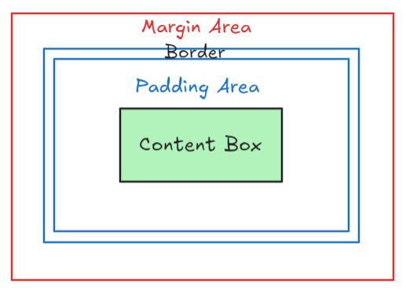
box-sizing Property ⇒
The CSS box-sizing property allows us to include the padding and
border in an element's total width and height.
If you set box-sizing: border-box; on an element, padding and border
are included in the width and height

2. Components of Box Model
There are mainly 4 components of Box model are as follows :
1. Content
2. Padding
3. Border
4. Margin

3. Content
The content of the box, where text and images appear.
4. Padding
The CSS padding property is used to generate space around an elements content, inside of any defined border’s.
The surrounding area of the content is called as padding.
The padding it falls inside of an element’s border, should an element have a border.
The padding property is used to provide spacing directly within an element
There are property values for setting the padding for each side of an element (top, right, bottom, and left)
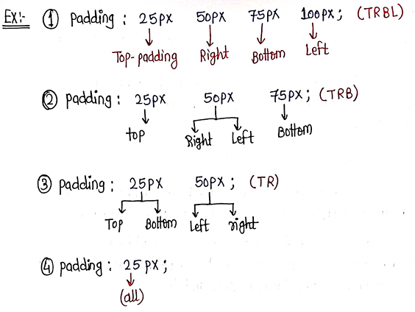
5. Border
A border that goes around the padding and content.
Borders fall between the padding and margin, providing an outline around an element.
The border property requires three values : width , style , and color
The CSS border properties are given below:
1.
border-width border-width : 1px|2px|5px;

2.
border-style border-style : solid|dotted|dashed|double|groove|ridg
e|inset|outset|none|hidden;

3.
border-color
4.
border-radius

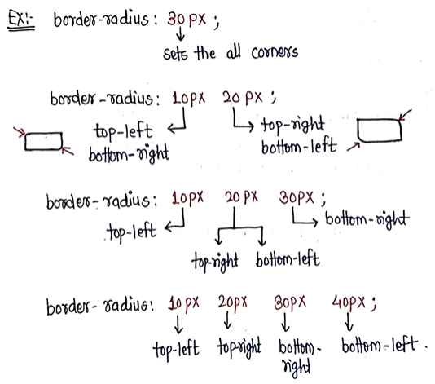

6. Margin
The CSS margin property is used to create a space around elements,
outside of any defined borders.
With CSS we can have full control over the margins.
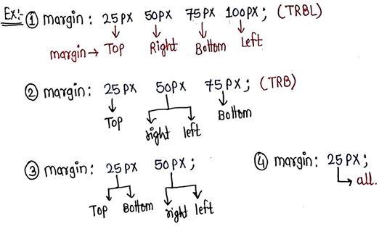

⇒ CSS Colors
1. CSS Colors
CSS Colors are an essential part of web design, providing the ability to bring your HTML elements to life.
2. Defining Color Values
1. Color Name :
Syntax: h1 {
color: color-name;
}

- RGB Format :
Syntax ⇒
rgb (red, green, blue)
rgb (255, 0, 0) ⇒ red
rgb (0, 255, 0) ⇒ green
rgb (0, 0, 255) ⇒ blue
rgb (0, 0, 0) ⇒ black
rgb (255, 255, 255) ⇒ white

- RGBA Format
Syntax ⇒
rgba (red, green, blue, alpha)
The alpha parameter is a number between 0-1
0 ⇒ Fully transparent
1 ⇒ Not transparent at all

4. Hexadecimal Notation (HEX)

Syntax ⇒
#rrggbb
For Example ⇒ #ff0000 → red
because red is set to its highest value (ff)
and the others are set to lowest value (00).
To display black, set all values to 00 ⇒ #000000
To display white, set all the values to ff ⇒ #ffffff

⇒ CSS Gradients
1. CSS Gradients
CSS gradients let you display smooth transitions between two or more specified colors.
Gradient is the combination of two or more colors.
To provide to smooth transition between two colors

2. Types of Gradients
CSS defines three types of gradients:
1. Linear Gradients (goes down/up/left/right/diagonally)
2. Radial Gradients (defined by their center)
3. Conic Gradients (rotated around a center point)

3. Linear Gradients
To create a linear gradient you must define at least two color stops.
Color stops are the colors you want to render smooth transitions among

Syntax ⇒
background-image: linear-gradient(direction, color-stop1, c
olor-stop2, ...);

Directions ⇒
1. Top to Bottom (By default) ⇒ to bottom
2. Bottom to Top ⇒ to top
3. Left to Right ⇒ to right
4. Right to Left ⇒ to left
5. Top Left to Bottom Right ⇒ to bottom right
6. Bottom Right to Top Left ⇒ to top left
7. Top Right to Bottom Left ⇒ to bottom left

Repeating Linear Gradient ⇒
The repeating-linear-gradient( ) function is used to repeat linear
Gradients

4. Radial Gradients
A radial gradient is defined by its center.
To create a radial gradient you must also define at least two color stops.
Syntax ⇒
background-image: radial-gradient(shape size at position, s
tart-color, ..., last-color);
By default, shape is ellipse .

5. Conical Gradients
A conic gradient is a gradient with color transitions rotated around a center point

To create a conic gradient you must define at least two colors.
Syntax ⇒
background-image: conic-gradient(red, blue, yellow);

⇒ CSS Background Properties
1. background
The CSS background properties are used to add background effects for elements.
The background property is a shorthand property.
In CSS, the background is the area behind an element’s content.

2. background-color
The background-color property is used to specify the background color of the element.
Syntax ⇒
background-color : red, blue, etc.;
3. background-image
The background-image property is used to set an image as a background of an element.
By default, the image is repeated so it covers the entire element.
Syntax ⇒
background-image : url(”path”);

4. background-repeat
The background-repeat property sets if/how a background image will be
repeated.
By default, the background-image property repeats the background image horizontally and vertically.
Some images are repeated only horizontally or vertically.
Syntax ⇒
background-repeat: repeat|repeat-x|repeat-y|no-repeat|initi
al|inherit
background-size
The background-size property specifies the size of the background images.
Syntax ⇒
background-size: auto|length|cover|contain|initial|inherit;

⇒ CSS Positions
1. CSS Positions
The position property specifies the type of positions method used for an element.
CSS positioning allows you to control the layout of HTML elements using properties such as top, right, bottom, and left.
The position property can help you manipulate the location of an element

There are 5 different position values ⇒
1. static (Default)
2. relative
3. absolute
4. fixed
5. sticky
Elements are then positioned using the top, right, bottom and left
properties.
These properties will not work unless the position property is set first.

2. Static
HTML elements are positioned position: static;by default.
Static positioned elements are not affected by the top, right, bottom, and left properties.
It is always positioned according to the normal flow of the page.

Syntax ⇒
position : static;

3. Relative
An element with position: relative; is positioned relative to its normal
position. With the help of top, right, bottom, and left properties we can adjust its relative position of element to its normal position.
Syntax ⇒
position : relative;
4. Absolute
An element with position: absolute is positioned relative to nearest relative parent element.
However; if an absolute positioned element has no positioned ancestors, it uses the document body, and moves along with page scrolling.
Note ⇒ Absolute positioned elements are removed from the normal flow, and can overlap elements.
Syntax ⇒
position : absolute;

5. Fixed
An element with position: fixed;
is positioned relative to the viewport, which means it always stays in the same place even if the page is scrolled.
With the help of properties like left, right, top, bottom we can fix the location of element.
A fixed element does not leave a gap in the page where it would normally have been located
.
Syntax ⇒
position : fixed;

6. Sticky
An element with position: sticky; is positioned based on the user's scroll
position.
A sticky element toggles between relative and fixed , depending on the scroll position.
NOTE ⇒
You must specify at least of top , right, bottom , or leftfor sticky
positioning to work.
Syntax ⇒
position: sticky;

⇒ CSS Flex Box
1. Introduction of CSS Flexbox
CSS Flexbox is used to make flexible layout as well as responsive layout
without using float and positioning.
It is 1 dimensional layout because it works primarily in one dimension (row
or column).
2. Features of Flexbox
High Flexibility
Arrangement & alignment of items
Proper spacing
Order & sequencing of items

. Flexbox Components
Flexbox components is divided into 2 sections:
1. Flex Container ⇒ The flex container becomes flexible by setting the
display property to flex.
2. Flex Items ⇒ The items present inside the flex container.
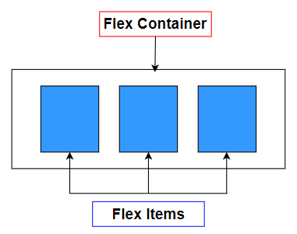
. Flexbox Axes
Flexbox works on two axes:
Main Axis ⇒ Runs from left to right by default.
Cross Axis ⇒ Perpendicular to main axis, runs from top to bottom
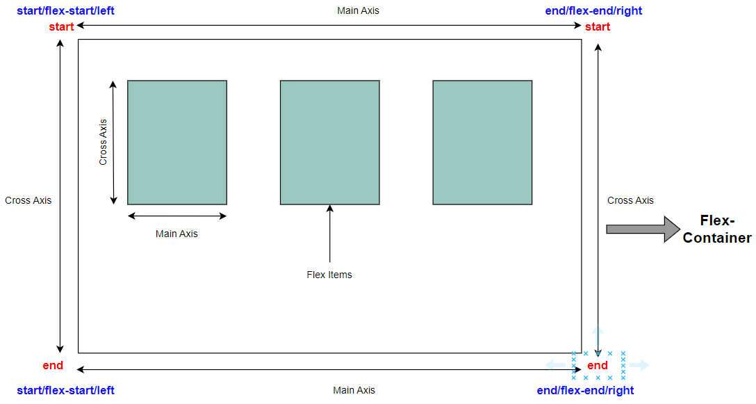
Flexbox Properties
1. Parent Properties
1. display
Defines a flex container.
Always provide the display : flex; property to parent container.
Syntax ⇒
display : flex
2. justify-content
The justify-content property is used to align the flex items.
It aligns the items along the main axis.
Syntax ⇒
justify-content: flex-start|flex-end|center|space-between|space-around|space-evenly;
justify-content: flex-start | start;
The flex-start value aligns the flex items at the beginning of the
container (this is default).
Syntax ⇒
.flex-container {
display: flex;
justify-content: flex-start;
}
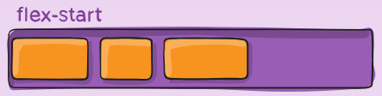
justify-content: flex-end | end;
The flex-end value aligns the flex items at the end of the
container.
Syntax ⇒
.flex-container {
display: flex;
justify-content: flex-end;
}
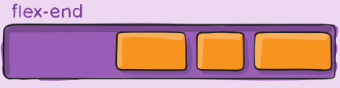
justify-content: center;
The center value aligns the flex items at the center of the
container.
Syntax ⇒
.flex-container {
display: flex;
justify-content: center;
}
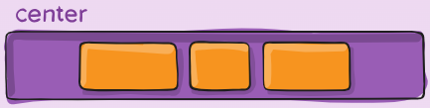
justify-content: space-between;
The space-between value displays the flex items with space
between the lines.
Syntax ⇒
.flex-container {
display: flex;
justify-content: space-between;
}
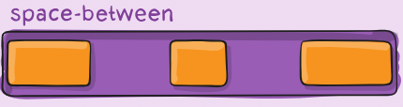
justify-content: space-around;
The space-around value displays the flex items with space before,
between, and after the lines.
Syntax ⇒
.flex-container {
display: flex;
justify-content: space-around;
}
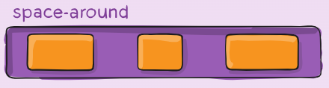
justify-content: space-evenly;
The space-evenly value displays the flex items with space is equal
(same) any two items .
Syntax ⇒
.flex-container {
display: flex;
justify-content: space-evenly;
}
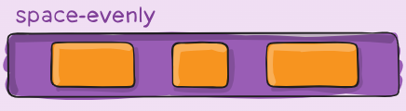
2. align-items
The align-items property is used to align the flex items.
Aligns multiple lines of items on the cross axis.
Syntax ⇒
.container {
align-items: stretch | flex-start | flex-end | center | baseline | first baseline | last baseline | start | end | self-start;
}

align-items: flex-start; (Default)
The flex-start value aligns the flex items at the top of the
container.
Syntax ⇒
.flex-container {
display: flex;
align-items: flex-start;
}
Example ⇒
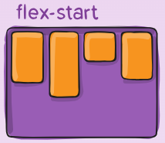
align-items: flex-end;
The flex-end value aligns the flex items at the bottom of the
container.
Syntax ⇒
.flex-container {
display: flex;
align-items: flex-end;
}
Example ⇒
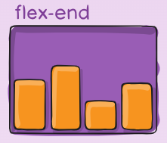
align-items: center;
The center value aligns the flex items in the middle of the
container.
Syntax ⇒
.flex-container {
display: flex;
align-items: center;
}
Example ⇒
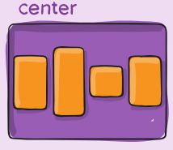
align-items: stretch;
The stretch value stretches the flex items to fill the container.
Syntax ⇒
.flex-container {
display: flex;
align-items: stretch;
}
Example ⇒
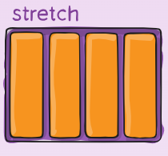
align-items: baseline;
The baseline value aligns the flex items such as their baselines
aligns.
Syntax ⇒
.flex-container {
display: flex;
align-items: baseline;
}
Example ⇒
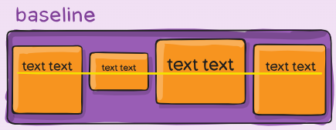
2. flex-direction
Defines the main axis direction.
By default flex-direction : row; for display flex property.
Syntax ⇒
.container {
flex-direction: row | row-reverse | column | column
-reverse;
}
flex-direction : row;
row (default): left to right in ltr ; right to left in rtl
Example ⇒
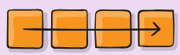
flex-direction : row-reverse;
row-reverse : right to left in ltr ; left to right in rtl
Example ⇒
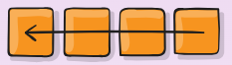
flex-direction : column;
column : same as row but top to bottom
Example ⇒
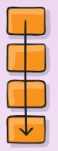
flex-direction : column-reverse;
column-reverse same as row-reverse but bottom to top
Example ⇒
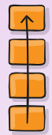
3. flex-wrap
By default, flex items will all try to fit onto one line.
The flex-wrap property specifies whether the flexible items should
wrap or not.
You can change that and allow the items to wrap as needed with this property.
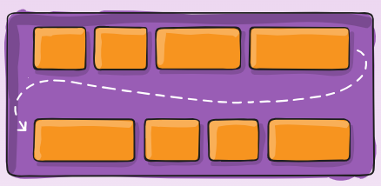
nowrap (default): all flex items will be on one line
wrap : flex items will wrap onto multiple lines, from top to bottom.
wrap-reverse : flex items will wrap onto multiple lines from bottom to
top.
Syntax ⇒
.container {
flex-wrap: nowrap | wrap | wrap-reverse;
}
Example ⇒
<!DOCTYPE html>
<html lang="en">
<head>
<meta charset="UTF-8">
<meta name="viewport" content="width=device-widt
h, initial-scale=1.0">
<title>Flex-Wrap</title>
<style>
.container {
width: 600px;
height: 300px;
border: 2px solid;
display: flex;
justify-content: space-around;
align-items: center;
/* Add here flex-wrap property */
flex-wrap: wrap;
}
.box {
width: 100px;
height: 100px;
border: 1px solid;
background-color: teal;
color: white;
text-align: center;
}
</style>
</head>
<body>
<div class="container">
<div class="box">Box-1</div>
<div class="box">Box-2</div>
<div class="box">Box-3</div>
<div class="box">Box-4</div>
<div class="box">Box-5</div>
<div class="box">Box-6</div>
<div class="box">Box-7</div>
<div class="box">Box-8</div>
<div class="box">Box-9</div>
<div class="box">Box-10</div>
</div>
</body>
</html>
Without Wrap
flex-wrap: no-wrap (By Default ) ⇒
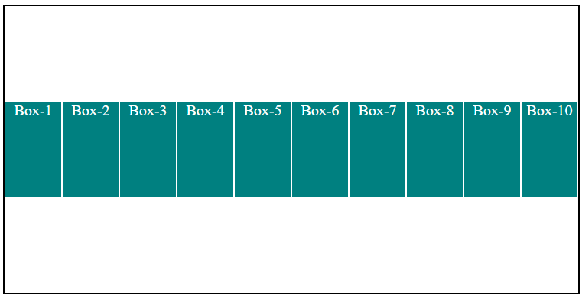
By using Wrap flex-wrap: wrap =>
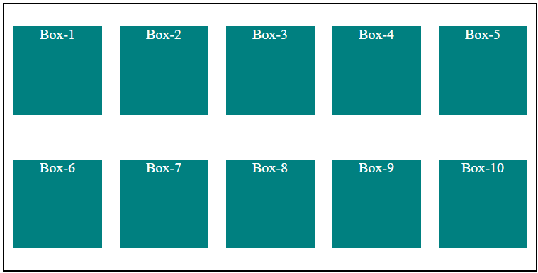
By using Wrap flex-wrap: wrap-reverse ⇒
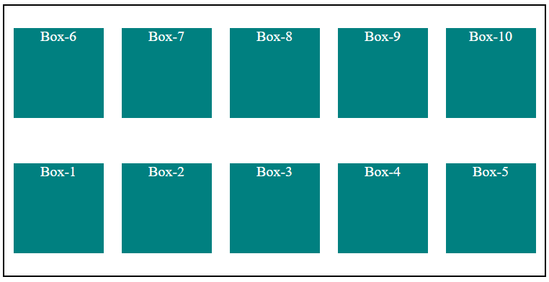\
4. flex-flow
The flex-flow property is a shorthand property for
flex-direction flex-wrap
Default value for flex-flow is row nowrap
.
Syntax ⇒
.container {
display: flex;
flex-flow: flex-direction flex-wrap;
}
5. align-content
This aligns a flex container’s lines within when there is extra space
in the cross-axis.
similar to how justify-content aligns individual items within the main
axis.
NOTE ⇒
This property only takes effect on multi-line flexible
containers, where flex-wrap is set to either
wrap or wrap-reverse . A single-line flexible container (i.e. where
flex-wrap is set to its default value, no-wrap ) will not reflect
align-content .
Syntax ⇒
.container {
align-content: flex-start | flex-end | center | spa
ce-between | space-around | space-evenly | stretch |
start | end | baseline | first baseline;
}

2. Child Properties
1. order
The order property specifies the order of a flexible item relative to
the rest of the flexible items inside the same container.
By default, flex items are laid out in the source order.
However, the order property controls the order in which they appear in the flex container.
By default order value is 0 (zero) .
Syntax ⇒
.item {
order: number;
}
Example ⇒
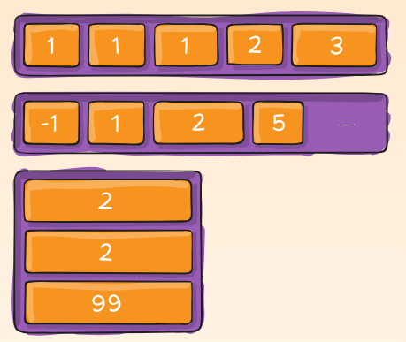
Example ⇒
<!DOCTYPE html>
<html lang="en">
<head>
<meta charset="UTF-8">
<meta name="viewport" content="width=device-widt
h, initial-scale=1.0">
<title>Order</title>
<style>
.container {
width: 600px;
height: 300px;
border: 2px solid;
display: flex;
justify-content: space-evenly;
align-items: center;
}
.box {
width: 100px;
height: 100px;
background-color: teal;
text-align: center;
line-height: 100px;
color: white ;
}
#box1 {
order: -2;
}
#box2 {
order: 4;
}
#box3 {
order: 0;
}
#box4 {
order: 2;
}
#box5 {
order: -3;
}
</style>
</head>
<body>
<div class="container">
<div class="box" id="box1">Box-1</div>
<div class="box" id="box2">Box-2</div>
<div class="box" id="box3">Box-3</div>
<div class="box" id="box4">Box-4</div>
<div class="box" id="box5">Box-5</div>
</div>
</body>
</html>
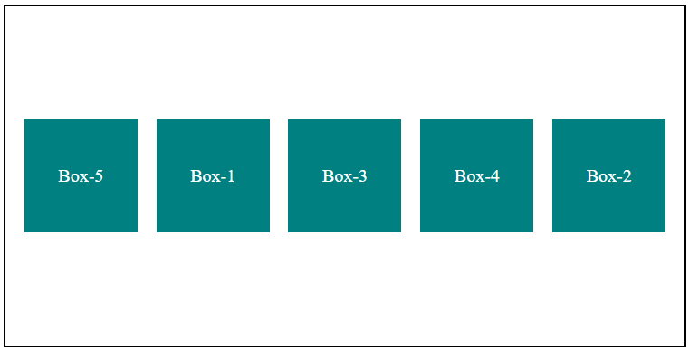

2. flex-grow
The flex-grow property specifies how much the item will grow
relative to the rest of the flexible items inside the same container.
This defines the ability for a flex item to grow if necessary.
By default value for flex-grow is 0 (zero) .
Syntax ⇒
.item {
flex-grow: number;
}
Example ⇒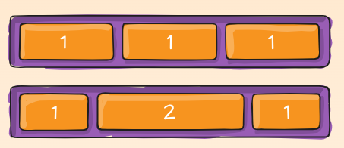

3. flex-shrink
The flex-shrink property specifies how the item will shrink relative to
the rest of the flexible items inside the same container.
By default value for flex-grow is 1 .
Negative numbers are invalid.
Syntax ⇒
.item {
flex-shrink: number;
}
4. flex-basis
The flex-basis property in CSS is used to specify the initial size of
the flexible item.
The flex property is not used if the element is not flexible item.
Default value is auto .
Syntax ⇒
.item {
flex-basis: number | auto | initial | inherit;
}

⇒ CSS Grid Model
1. Grid Layout
The CSS Grid Layout Module offers a grid-based layout system, with rows and columns,
making it easier to design web pages without having to use floats and positioning.
2. Core Concepts of Grid
Grid container
Grid Items
3. Grid Container → display
An HTML element becomes a grid container when its
display:grid property is set to grid.
Syntax ⇒
.container {
display: grid;
}
4. Grid Columns
The vertical lines of grid items are called columns.
5. Grid Rows
The horizontal lines of grid items are called rows.
6. Grid Gaps
The spaces between each column/row are called gaps.
Syntax ⇒
row-gap : 10px;
column-gap: 10px;
The gap property is a shorthand property for the
row-gap and the column-gap properties:
Syntax ⇒
gap:10px;

7. Grid Line
Column lines
⇒ The lines between columns are called column lines.
Row Lines
⇒ The lines between rows are called row lines.
8. Grid Container Properties (Parent Properties)
1. grid-template-columns property
2. grid-template-rows property
3. justify-content Property
4. align-content Property
1. grid-template-columns property
The grid-template-columns property defines the number of columns in
your grid layout, and it can define the width of each column.
The value is a space-separated-list, where each value defines the
width of the respective column.
Lets consider I want to create a 3 columns :
Syntax ⇒grid-template-columns: auto auto auto;
100px 200px 300px;
1fr 2fr 1fr;
10% 20% 30%;
repeat(3, 100px);
100px 200px auto 300px;

2. grid-template-rows property
The grid-template-rows property defines the height of each row.
Lets consider I want to create a 3 rows :
Syntax ⇒
grid-template-rows: auto auto auto;
100px 200px 300px;
1fr 2fr 1fr;
10% 20% 30%;
repeat(3, 100px);
100px 200px auto 300px;

3. justify-content Property
The justify-content property is used to align the whole grid inside the
container.
Syntax ⇒
justify-content: start|center|end|space-evenly|space-aro
und|space-between;

4. align-content Property
The align-content property is used to vertically align the whole grid
inside the container.
Syntax ⇒
align-content: start|center|end|space-evenly|space-aroun
d|space-between;

9. Grid Items Properties (Child Properties)
1. grid-column Property
2. grid-row Property
1. grid-column property
The grid-column property defines on which column(s) to place an item.
You define where the item will start, and where the item will end.
It is nothing but the merging of columns in horizontal direction.
Syntax ⇒
grid-column: 1 / 3 ;(1st way)
grid-column: 1/span 2;(2nd way)
Here 1 is the grid-starting column.
and 3 is the grid-ending column.
NOTE ⇒
grid-column is the shorthand property for the grid-column-start
and grid-column-end .
You can separate both the properties instead of the shorthand property grid-column.
2. grid-row property
The grid-row property defines on which row(s) to place an item.
You define where the item will start, and where the item will end.
It is nothing but the merging of rows in vertical direction.
NOTE ⇒
Always remember one thing we have to first define the column
number in which you are merging the rows.
Syntax ⇒
grid-column: 2; (here that means I want to merge rows in
column 2)
grid-row: 1 / 3 ;(1st way)
grid-row: 1/span 2;(2nd way)
Here 1 is the grid-starting row.
and 3 is the grid-ending row.
NOTE ⇒
grid-row is the shorthand property for the
Grid-row-start and grid-row-end .
You can separate both the properties instead of the shorthand property
grid-row.
11. grid-area property
The grid-area property can also be used to assign names to grid items.
Syntax ⇒
grid-area: name_of_the_grid;
Example ⇒
#item1 {
grid-area: header;
}
#item2 {
grid-area: aside;
}
#item3 {
grid-area:article;
}

⇒ CSS Transformation
1. CSS Transformation
An Object can change the original form to desired form this is called as
transformation.
The transform property applies a transformation to an element.
This property allows you to rotate, scale, skew, etc., elements.
2. CSS 2D Transform Methods
With the CSS transform property we can used ⇒
1. translate(), translateX(), translateY()
2. rotate(), rotateX(), rotateY()
3. scale(), scaleX(), scaleY()
4. skew(), skewX(), skewY()
The
transform
property in CSS is used to add effects like skew, rotate,
translate, etc on elements.
3. translate() property
The
translate()
method moves an element from its current position.
Syntax ⇒
transform: translate(x,y);
translateX(x): It specifies the translation across the X-axis only.
translateY(y): It specifies the translation across the Y-axis only.
4. rotate() property
The rotate() method rotates an element clockwise or counter-clockwise
according to a given degree.
Using negatives values will rotate the element in anti-clockwise direction.
It accepts only deg. (0deg to 360deg).
Syntax ⇒
transform: rotate(angle);
rotate(angle): It specifies the angle of rotation.
rotateX(angle): It specifies the rotation along with the X-axis
corresponding to the angle of rotation.
rotateY(angle): It specifies the rotation along with the Y-axis
corresponding to the angle of rotation.
rotateZ(angle): It specifies the rotation along with the Z-axis
corresponding to the angle of rotation.
5. scale() property
The scale() method increases or decreases the width and height of an
element.
It accepts only number.
If you provide the number ( >1 => It will increases the size of the element)
If you provide the number ( <1 and >0 => It will decrease the size of the element)
If you provide the number ( <0 => It will increase the size of the element but it will invert the element.)
Syntax ⇒
transform: scale(number);
scaleX() => The scaleX() method increases or decreases the width of and
element.
scaleY() => The scaleY() method increases or decreases the height of
element.
6. skew() property
The skew means to pick a point and push or pull it in a different directions.
The skew() method skews an element along the X and Y axis by the given angles.
It accepts only deg.
Syntax ⇒
transform: skew (X deg, Y deg);
skewX() => The skewX() method skews an element along the x-axis by the given angle.
skewY() => The skewY() method skews an element along the y-axis by the given angle

9 ⇒ CSS Transition
1. CSS Transition
A transition occurs when a CSS property changes from one value to another value over a period of time.
2. CSS Transition Properties
Following are the CSS transition properties ⇒
1. transition-property
2. transition-duration
3. transition-timing-function
4. transition-delay
3. transition-property
The transition-property property allows you to select the CSS properties
that you want to animate during the transition(change).
Syntax ⇒
transition-property: specific-property-name | all;
4. transition-duration
The transition-durationproperty in CSS specifies the duration over which a transition effect occurs.
It defines how long it takes for a CSS property to change from one state to another.
Syntax ⇒
transition-duration: time (in s or ms);

5. transition-timing-function
The transition-timing-function
property specifies the speed curve of the
transition effect.
It determines how CSS properties change values over time during
transitions.
This curve, or easing function, defines the rate of change, influencing the
smoothness and perception of animation transitions on web elements.
Syntax ⇒
transition-timing-function: linear =>same speed throught th
e the transition effect
ease(Default) =>slow start, then fast, end slowly
ease-in => slow start
ease-ou t => slow end
ease-in -out => slow start and end
6. transition-delay
The transition-delay provides the delay for the transition effect.
Syntax ⇒
transition-delay: time (in s or ms);
7. transition (shorthand Property)
We can use directly shorthand property for transition for all the 4 values.
Syntax ⇒
transition: transition-property transition-duration transit
ion-timing-function transition-delay
Example ⇒
transition : all 0.5s linear 2s;

⇒ CSS Animations
1. CSS Animations
An animation makes an element change gradually from one style to
another.
You can add as many as properties you want to add. We can also specify
the changes in percentage.
0% specify the start of the animation and 100% specify its completion.
CSS animations make it possible to animate transitions from one CSS style
configuration to another.
2. What is animation exactly?
Animation is a method in which figures are manipulated to appear as
moving images.
3. Advantages of animations
1. Easy to use simple animations
2. It is not required to hover the element to see the changes by default it is
automatically will start the changes.
3. It perform smooth on under moderate system load.
4. Animation Syntax
1st way
: when only start and end is there.
Syntax ⇒
@keyframes identifier {
from {
properties;
}
to {
properties;
}
}
2nd way
: when you have to provide in stages or phases.
Syntax ⇒
@keyframes identifier {
0% {
properties;
}
10% {
properties;
}
20% {
properties;
}
.
.
.
.
100% {
properties;
}
}
Here, identifier it is nothing but the name of the animation.
Also, The CSS
@keyframes
rule is used to control the steps in an animation
sequence by defining CSS styles for points along the animation sequence.
5. CSS Animations properties
1. animation-name
2. animation-duration
3. animation-timing-function
4. animation-delay
5. animation-iteration-count
6. animation-name
Specifies the name of the @keyframes at-rule describing the animation’s
keyframes.
Syntax ⇒
animation-name: name_of_the_animation (text);
7. animation-duration
It configures the length of time that an animation should take to complete
one cycle.
Syntax ⇒
animation-duration: time (in s or ms)
8. animation-timing-function
Configures the timing of the animation; that is, how the animation
transitions through keyframes, by establishing acceleration curves.
Syntax ⇒
animation-timing-function: linear =>same speed throught the
the animation effect
ease(Default) =>slow start, then fast, end slowly
ease-in => slow start
ease-out = > slow end
ease-in-out => slow start and end
9. animation-delay
The animation-delay property specifies a delay for the start of an animation.
Defined in seconds (s) or milliseconds (ms), this value determines how
long to wait before beginning the animation.
Negative values start the animation as if it had already been playing for the
specified duration.
Syntax ⇒
animation-delay: time (in s or ms);
10. animation-iteration-count
The
animation-iteration-count
property in CSS specifies the number of times
an animation should be repeated.
It can also be set to infinite to repeat the animation indefinitely.
Syntax ⇒
animation-iteration-count: number | infinite;

1 ⇒ CSS Media
Queries
1. CSS Media Queries
The @media rule, introduced in CSS2, made it possible to different style
rules for different media types.
Media Queries in CSS3 extended in CSS2 media types idea.
Instead of looking for a style or a type of a device they look at the
capability of the device.
Media Queries can be used to check many things such as:
1. Width and height of the viewport.
2. Orientation of the viewport (Landscape or Portrait)
3. Resolution
Using Media queries are a popular technique for developing a responsive
for the desktops, laptops, and mobile phones.
Simple use of media queries is that it will adapt the resolution according the
screen size and change the styles of an element as per requirement of the
screen size.
2. Why do we use media queries?
We use CSS media queries for making a responsive design of web page
according to each and every screen size with the help of some
breakpoints.
3. Media Query Syntax
A media query consists of a media type and can contain one or more media
features which resolve to either true or false.
Syntax ⇒
@media mediatype (media-feature) and (media-feature) {
CSS Code;
}
The anatomy of media queries ⇒
Typical Device Breakpoints ⇒
1. Extra small devices (phones, 600px and down) → @media only screen
and (max-width: 600px) {...}
2. Small devices (portrait tablets and large phones, 600px and up) →
@media only screen and (min-width: 600px) {...}
3. Medium devices (landscape tablets, 768px and up) → @media only
screen and (min-width: 768px) {...}
4. Large devices (laptops/desktops, 992px and up) → @media only
screen and (min-width: 992px) {...}
5. Extra large devices (large laptops and desktops, 1200px and up) →
@media only screen and (min-width: 1200px) {...}
Media Type ⇒
1. screen → Used for computer screens, tablets, smart-phones etc.
2. print → Used for print preview mode
3. speech → Used for screen readers purpose.
4. all → Matches all the device type.
Orientation ⇒ Media queries can also be used to change layout of a page
depending on the orientation of the browser.
1. landscape
2. portrait

